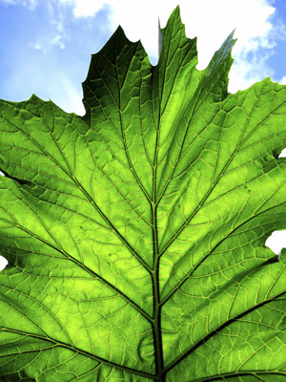**Photosynthesis Inquiry Lab**

**Plant Breeding Chi2 Analysis**

Objectives:

* Formulate hypotheses about photosynthesis.
* Use paper chromatography to separate photosynthetic pigments.
* Use a spectrophotometer to determine the absorption spectra for photosynthetic pigments and graph these values.
* Design your own experiment to test factors that influence photosynthesis in a fast-growing species of plant.
* Collect data and analyze your results.

|  |  |
| --- | --- |
| Time (weeks) | Laboratory Work |
| Week 1 | * Read entire lab * Complete the background lab questions * Learn methods for examining photosynthesis * Plant WFPs |
| Week 2 | * Water and take data * Create WFP growth tables * Learn WFP life cycle |
| Week 3 | * Pollinate WFPs * Do photosynthesis inquiry lab with one or two WFP leaves |
| Week 4 | * Create graphs, analyze data, answer discussion questions and REE PE PA (conclusion) for photosynthesis lab |
| Weeks 5-6 | * Cultivate WFP seeds * Plant WFP F2 generation |
| Weeks 7-8 | * Collect WFP F2 data * Make table to analyze * Perform Chi2 (x2) analysis |

**Background:**

Photosynthesis- it happens all around us, but how often do we pause to think of the consequences? Life as we know it could not exist without it. Photosynthesis captures the sun’s energy and uses it to convert Carbon dioxide (CO2) and water (H20) into sugar. In photosynthetic plants and algae, the process releases oxygen (02). In fact virtually all of the oxygen we breathe was liberated from water through photosynthesis. All the starch we eat, that insoluble polysaccharide made from sugar, was made by plants as a way of storing the sugars they created through photosynthesis. Our lives are absolutely dependent upon the photosynthesis that occurs in other organisms.

Think again about this photosynthetic reaction: through photosynthesis, green plants *remove* **CO2** from the air, and **release O2**. Since the present global warming crisis is being caused primarily but the rise in atmospheric CO2 levels from our burning of fossil feels, what do you think the effect of green plants is on the earth’s climate? What effect do you think the intense harvesting of our rain forests is having on the planet’s climate? Write you’re answered in your **Lab Notes** at the end of the chapter.

You will be experimenting with photosynthetic organisms over the next few weeks. Your first job is to examine in more detail how green plants carry out photosynthesis. You will then be using that knowledge to design your own experiments. You will be using plants you grow from seed. We will use a fast-growing species from the bean family, **Fabaceae** (Fast-Plants for short).

Your *Fast Plants* will germinate quickly and in a few days will be showing their first leaves, their cotyledons. There are a number of questions you can be asking of your plant . The questions you come up with should address your own questions about photosynthesis.

The next several sections will give you substantial background information on photosynthesis. Think of possible questions you might ask in you experiment as you study these sections. At the end of these sections, you will be asked to poise two of the questions you came up with.

**PHOTOSYNTHESIS OCCURS WITHIN CHLOROPLASTS OF PLANTS**

In the photosynthetic organisms we are most familiar with, eukaryotic plants and algae, photosynthesis occurs within specialized organelles call **chloroplasts**.

Chloroplasts contain various **pigments** that **capture light energy**, and pass this energy along to **electron transport chains** to make **ATP**. Think about this! **Plants** use **pigments** to capture **energy** from the **sun** and **transform**  that energy into a usable form for themselves. (We could learn a lot from plants about energy production!) Since Plants are vital to the health of this planted, knowing how plants do this is important to us as caretakers of our planet.

We already know a great deal about this process (review what you’ve read in you textbook). We know, for example, that plants need **water** in addition to **light** to make ATP during photosynthesis. When using water during photosynthesis, they oxidize it, **releasing oxygen**. So, when plants are exposed to light, the make ATP and give off oxygen, and they need water to do this. (Can you think of ways of testing this?) This part of photosynthesis is called the **light-reaction** and it occurs in the thylakoid membranes of the chloroplast.

We also know that plants **use ATP to make glucose**, but they **need a carbon source** to do so, and the carbon source they use is **carbon dioxide**. This happens in the semi fluid stroma of the chloroplasts, and we call this part of photosynthesis the **Calvin Cycle**.

Druing photosynthesis, plants **use light** to take relatively low-energy compounds (**water and carbon dioxide**) and convert them into high-energy molecules (**sugar**), and they **give off oxygen** in the process – and they give off some water as well.

The overall equation of photosynthesis can be summarized as follows:

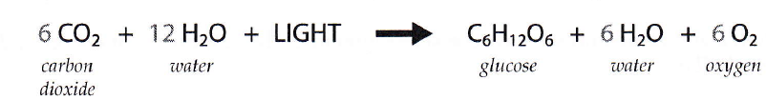

The two reactions of photosynthesis in plants are summarized below (**Figure 6.1**). The two processes are completely **independent**. For example, if light is absent, it is obvious that the light-dependent reaction will stop, but the Calvin cycle will also stop, since it depends upon a continual supply of ATP and NADPH from the light-dependent reaction. Conversely, if CO2 is absent the Calvin cycle will stop, but in addition the light-dependent reaction will also stop, since it requires a continual supply of ADP and NADP+ to continue.

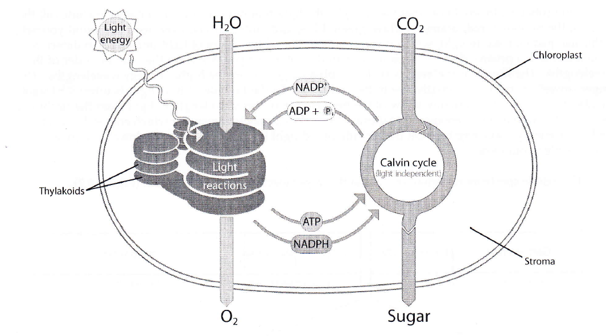

Figure 6.1: Photosynthesis in chloroplasts. In the light reactions, light energy is used to split water and create energy-rich molecules while releasing oxygen to the air. In the light-independent reactions (Calvin Cycle), the energy-rich molecules from the light reactions along with carbon dioxide from the air are used to make sugar.

Can you think of experiments you might conduct to test this interdependence? Suppose you were to limit light to your WFP? Or limit amounts of CO2? Figuring out *how* to conduct such experiments is one of your major challenges.

**LIGHT AND THE PIGMENTS OF PHOTOSYNTHESIS**

The profound event of photosynthesis couldn’t happen without pigments that are able to capture light’s energy. The major pigments involved are **chlorophylls and carotenoids**. You have already experienced both of these: chlorophylls give the green color to the grass stains on your pants when you kneel on a lawn; carotenoids stain your fingers when you grate carrots or stain your shirt orange when you drip tomato sauce.

There are several pigments we will be paying close attention to. **Chlorophyll *a*** is of primary importance since it is the only pigment that can directly pass electrons to the electron transport chains.

**Chlorophyll *b*** and **carotenoids** act as accessory pigments. They capture light energy and then pass it along to **chlorophyll *a***.

**PHOTOSYNTHETIC PIGMENTS ABOSRB IN THE VISIBLE SPECTRUM**

One aspect of photosynthesis that you might want to explore is the light absorbed by plant pigments. To do this, it is important to know several things about light. First, the light that photosynthetic pigments can absorb is all within the **visible spectrum.** This is convenient for us, since you will be able to see any wavelength of light you might want to test.

You probably already know that visible light, the light that our own eyes can detect, includes all the colors of the rainbow : **red, orange, yellow, green, blue, and violet.** If you ever need to remind yourself of this list, just take a white light, which is a combination of all the colors of light our eyes can detect, and you shine it through a prism—this will separate out all the colors for you, showing them in order of their wavelengths. The **shorter wavelengths** are in the **blue** range and are **higher energy** wavelengths. The **longer (lower energy)** wavelengths are in the **red** range. To the far side of blue light is ultraviolet light, invisible to our eyes. We certainly know of the high energy of this wavelength of light from the sunburns we can suffer from being overexposed to it (this also makes it easy to remember which end of the spectrum has higher energy wavelengths). On the far side of red light is infrared. These are lower energy and are also invisible to our eyes.

The visible spectrum is a small portion of the larger electromagnetic spectrum **(Figure 6.2).**

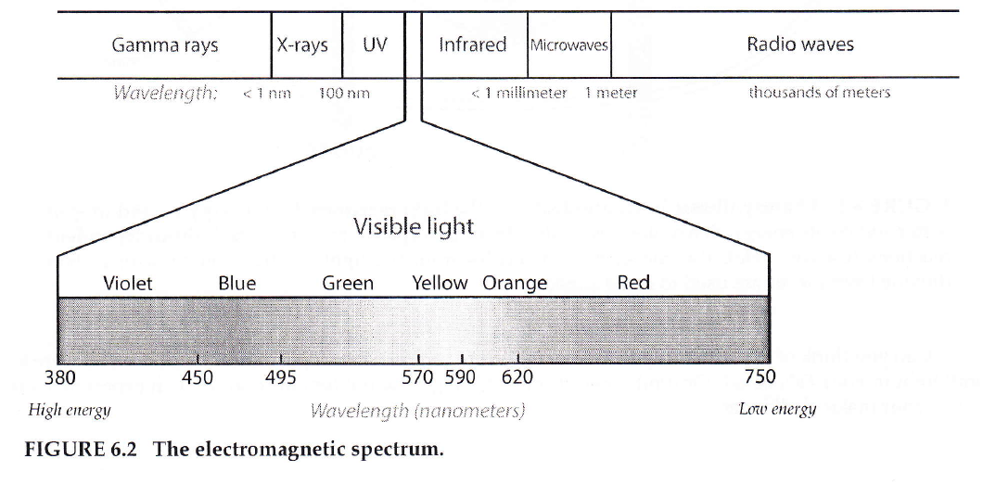

It is interesting that the wavelengths photosynthetic pigments absorb are all within our own visible spectrum! Do you have any ideas as to why?

In your experiments, you may be able to test the effects of different wavelengths of light on your plant. Make sure you think about the energy levels of these wavelengths when you are designing your experiment and again in your analysis. Would it be advantageous for a plant pigment to absorb a high-energy wavelength? Can you think of any advantages or disadvantages to absorbing a low-energy wavelength?

To help you remember which colors of light you could test, and the wavelengths and energy levels they correspond to, draw and label the visible spectrum in your **Lab Notes** at the end of the chapter (2). Use colored pencils, pens, or crayons, if you have them. Label which end of the spectrum has the highest-energy wavelengths, and which has the lowest-energy wavelengths.

**CHLOROPHYLLS**

We know from experience that chlorophylls are green (remember the grass stain on your pants). But what does this mean? What does it tells us about the wavelengths of light that plant pigments absorb? In order to design experiments using light, you will need to know very specifically what it means.

When we look at a leaf and say, “this leaf is green,” we are saying that is ***opaque object***(i.e., this object that is not transparent—we cannot see through it) is **reflecting green light back at us.** If we are looking at our leaf in white light and it appears green, then **all the colors in the visible spectrum** are being **absorbed** by that leaf ***except green***, and  **green** is being **reflected** back at us.

So, already you know something significant about the wavelengths of light absorbed by photosynthetic pigments that you could use to design an experiment. If plants look green, then their predominant pigments must be absorbing in the wavelengths ***outside*** the green range. What ranges of wavelengths would this be?

If you were to design an experiment using different colors of light, how would you create the colored light? In thinking about this, don't forget some of the things you know based on your own experiences. For example, unlike the opaque object that reflects light, the color of a *transparent object,* such as glass or cellophane, is the color of the wavelength of light that is **transmitted** through it; blue cellophane, for example, looks blue because only blue light **passes through** it. to?

**CAROTENOIDS ARE ACCESSARY PIGMENTS**

As we mentioned earlier, the yellow, orange, and red pigments of plants are the carotenoids (e.g., **carotene** and **xanthophylls**). Their concentration is lower than that of chlorophyll, so their color is usually masked by the green chlorophyll. Carotenoids assist in photosynthesis and absorb wavelengths not absorbed efficiently by chlorophylls. What wavelengths would these be? How do you think your plants would respond if you denied them light in these wavelengths? Again, these are the types of questions you can ask in your own experiments on your *Fast Plants*.

In addition to acting as accessory pigments for photosynthesis, carotenoids also are important for their protective functions. They act as antioxidants, reducing the oxygen radicals that can build up during photosynthesis. (so, why would oxygen radicals build up? Look back at the summary of photosynthesis: plants are giving off oxygen-oxygen, so necessary to us, is also a dangerous molecule because of oxygen radicals it can help form!)

Carotenoids act as antioxidants in us, as well, and therefore protect against diseases such as cancer that can be caused by oxygen radicals. We cannot take arytenoids ourselves, so all of the carotenoids we have must come from the food we eat. So “eat your *veggies”* is indeed very good advice.

**PHOTOSYNTHESIS RELIES ON MAGNESIUM**

There are certain minerals that are essential to photosynthesis, and one of these is magnesium. Magnesium is found at the center of the porphyrin ring of each chlorophyll molecule.

Interestingly, magnesium is also of major importance to you own health- it is used by excitatory tissues such as nerve and muscles, and when our diets are low in magnesium we can suffer from migraines, menstrual cramps, heart arrhythmias, and a host of other problems. So, when you physician told you to eat lots of green leafy vegetables, this one reason why.

Could you use your knowledge about magnesium being essential to building chlorophyll molecules to design an experiment? What do you think would happen to a plant grown in the absence of magnesium? Grown in soil augmented with magnesium? (Milk of magnesia, by the way, is a convenient source of magnesium.)

**PHOTOSYNTHESIS: YOUR TECHNIQUES OF ANALYSIS**

In your first lab session on photosynthesis, you will be learning techniques for examinging photosynthesis in plants. This will arm you with specific skills for examining the results of your own experiment. So, pay close attention. With each technique you learn about, ask yourself, “What questions can I answer using this technique? How might I use it in my own experiment?”

The next several sections are to get you started so when you get to lab, you will be well prepared for the hands-on process.

**COLLECTING LAB DATA ON YOUR FAST PLANT EXPERIMENT**

You have now been gathering data on your plants for several weeks. These data are extremely important for addressing the question you have asked. You now have an opportunity to add to these data by choosing a selection of tests to compare you experimental to you control plant. For this, you will use the techniques you learned in Part 1 of this lab series. Do as many of the tests as time allows or that you instructor advises.

**COMPARING AMOUNTS OF PHOTOSUNTHESIS BY WEIGHING PLANTS**

How much a plant has grown can be indirect measure of its photosynthetic activity during the growth period. You already have growth rates of your experiential and control. But you can add to this a comparison based on weight. If your lab has a scale that can weigh your plants, you can use that. Otherwise, you can construct a weighing device.

*Weighing device:* Tie equal lengths of string (about 6 inches, each) to the ends of a straw, and anchor them with tape. Tie a third string (about 6 inches) around the muddle of the straw. You are now going to calibrate your weighing device. Fashion two paperclips of equal size into hooks. Tie a hook to each string at the ends of the straw. Hold the weighing devices in the air, and adjust the middle string until the hooks on each side string hand down to the same level.

Think about how you will weigh your plants. Will you use the entire plant, including the roots? If so, how will you clean the roots of dirt? If using a classroom scale, weigh your experimental and control plants separately. If using your weighing device, hook the experimental and control plants to either end of your weighing device. Which plant hangs down lower than the other- this, obviously, I the heavier plant. At how much of an angle is you straw tipping? This angle is telling you the relative weights of the plants. The greater angle, the larger the difference in weight.

Record your results from weighing your plants in your **notebook**.

**CHLOROPHYLL EXTRACTIONS**

You can compare the amounts of photosynthetic pigments between your experimental and control by extracting the chlorophyll from your experimental and control.

To do this accurately, it is important that you use the same size leaf sample from the experimental and control, so you can compare the amount of chlorophyll per unit area of leaf.

* Remove one or two good-sized leaves from both experimental and control plants
* Take your control leaves, and use a scalpel or scissors and a ruler to cut out two squares of leaf that are 1.0 cm (or 0.5 inch) on a side. Put these in a test tube that you label “control.”
* Take your experimental leaves, and use a scalpel or scissors and a ruler to cut out two squares of leaf that are the same size as in your control, 1.0 cm, on a side. Put these in a test tube that you label “experimental.”
* Add 10 mL of 95% ethanol (EtOH) to each tube (do NOT use an automatic pipettor – the ethanol evaporates into the mechanism and jams the pipettes).
* Place the tubes in a water bath at 70 degrees Celsius and heat for 10 minutes: this will remove the chlorophyll from the leaves. *Be very careful that the water bath isn’t hotter since 95% ethanol evaporates at 78.4 degrees Celsius.*
* Remove the tubes from the water bath.
* Remove the pieces of leaf and place them in Petri dishes that are half full of water and that you have labeled “control” and “experimental.” You will be using these pieces of bleached leaves for further tests on starch content and number of chloroplasts, and they need to remain moist.
* Look at your two test tubes of alcohol leaf extract: the extract should look green. You can now compare the amount of chlorophyll that was in each leaf. Hold each test tube against white paper and compare their color to the color scale. Determine what shade of green matches your control and experimental test tubes. Determine if the experimental has more, the same, or less chlorophyll based on this comparison. Record your results in your lab notebook.

This is a relatively crude comparison of the amount of chlorophyll. A more accurate comparison can be made using spectrophotometry.

**SPECTROPHOTOMETRY**

To make a highly accurate comparison of the amount of chlorophyll in your “experimental” and “control” leaves, you can use the pigment extracts that you made in the section above for spectrophotometry readings.

|  |
| --- |
| Protocol for Using the Spectrophotometer |
| 1. Turn 0% knob to the right to turn the spec on. Let the spec warm up for at least 15 minutes before using. |
| 2. Set the mode to “transmittance.” |
| 3. Set your wavelength to the desired number. For this lab, think about the wavelengths where plants photosynthesize the most. |
| 4. Check to see that the sample holder is empty and closed. Do not slam the sample lid shut. Gently open and close the sample lid. |
| 5. Use the 0% knob (left knob) to set the transmittance to 0%. |
| 6. Wipe fingerprints from the blank, insert it, and set the transmittance to 100% using the 100% knob (right knob). |
| 7. Wipe fingerprints form your sample tube, insert it, change the mode to absorbance, and read the absorbance value. |
| 8. Repeat steps b. through f. for each sample you need readings on. |

Rather than reading the entire absorbance spectrum for your control and experimental tubes, all you need to do is take readings of absorbance at the peaks of absorbance for chlorophyll *a* and chlorophyll *b*.

Note that the in two types of chlorophyll each has one peak of absorbance in the absorption spectrum. For your purposes, you are trying to distinguish between the two chlorophylls, so you will want to look for peaks where the peak for chlorophyll a is farther away from the peak for chlorophyll b rather than closer to it. What are the wavelengths of these peaks, and which chlorophyll does each respond to? Record your answer in your lab notebook.

You can now take readings at wavelengths that include these peaks. Include the wavelengths you listed above, but include readings outside of this range as well. For example, take readings at three different wavelengths to provide a good range to take into account any shifting of the absorbance peaks based on the solvents used. (The absorbance peaks of chlorophyll depend in part upon the solvent the pigments are dissolved in. The absorption peaks for chlorophyll dissolved in alcohol, for example, are at wavelengths slightly longer than those of chlorophyll dissolved in ether.)

In taking your readings, you will want to first set the wavelength of the machine for one wavelength and take the readings for both the control and experimental. Then, recalibrate the machine for the second wavelength, and take the readings again for both the control and the experimental. Then, do the same for the third wavelength.

Create a graph of your results. Use Excel or graph paper. Think about what type of graph will be best for showing these results.

**COMPARING AMOUNT OF STARCH IN LEAVES USING LUGOL’S STAIN**

As a measure of how much photosynthesis might have occurred in your experimental compared to your control plant, you can measure the amount of starch in the leaves of each. The iodine in Lugol’s stain, upon interacting with starch (but not simple sugars), changes color from a dull brown to a dark blue/black.

You can use pieces of leaf in the Petri dishes from your alcohol extraction. Having removed the chlorophyll from these pieces allows you to see the starch that is left. It would be difficult to use the Lugol’s stain to measure starch if chlorophyll were still present because it would mask the color of the Lugol’s stain.

* Readjust the water in your Petri dish containing the leaves so that they are less than half-filled with tap water. Add approximately 20 drops of Lugol’s stain. Stain for five minutes.
* Remove the stained leaf pieces to white paper and allow to dry.
* The iodine in Lugol’s stain will stain starch blue. Move your leaf pieces to a clean part of the white paper. Record the color of each leaf using a numeric scale you create as a class. Rank you leaf color on the scale from 1-10. (If the paper also stains blue, what does that tell you about the paper?)

**COMPARING NUMBER OF CHLOROPLASTS IN LEAVES**

You can compare your experimental and control by comparing the number of chloroplasts in their leaves. You obviously do not want to count all the chloroplasts in a leaf, so the best way to do this is to choose several cells, and count only the number of chloroplasts that you see in these.

Make a wet-wholemount using a small piece (1 cm) of leaf from control and experimental plants (you should use the pieces of leaf left from your alcohol extraction). Put the pieces of leaf on slides, add a drop of water. Put a coverslip over the leaf. Add more water from the side of the coverslip if needed.

The cells that show their chloroplasts most clearly are the stomata guard cells. These are the cells that surround the stomata (the openings in the leaves for gas exchange).

Count the number of chloroplasts in several cells of both the control and experimental leaves. Determine the average number of chloroplasts per cell in the control versus the experimental using your counts. Record your results in a data table.

**PHOTOSYNTHESIS: EXPERIMENTS WITH WISCONSIN FAST PLANT (WFP)**

**PRE-LAB QUESTIONS:**

1. The global warming crisis is being caused primarily by our increased production of CO2. What do you think the effect of green plants is on the earth’s climate? What effect do you think the intense harvesting of our rain forests is having on the planet’s climate?
2. Draw and label the visible spectrum. Use colored pencils, pens, or crayons, if you have them. Label which end of the spectrum has the highest-energy wavelengths, and which end has the lowest-energy wavelengths.
3. If plants look green, then their predominant pigments must be absorbing in the wavelengths outside the green range. What ranges of wavelengths and colors would this be?
4. What is your hypothesis about what would happen to plants grown under each of the following conditions? Explain your reasoning in each case.

* Grown in green light?
* Grown in blue light?
* Grown in red light?

1. What wavelengths do you think carotenoid pigments absorb? How do you think plants would respond if denied light in these wavelengths? Explain your reasoning.
2. What do you think would happen to a plant grown in the absorbance of magnesium? In an abundance of magnesium? Explain your reasoning.
3. Spinach leaves are dark green. From the green color, what pigments would you expect? What other pigments could be there? List all the pigments that might be in the spinach leaf.
4. Hypothesis: Formulate a hypothesis about what the absorption spectrum is for each of the three pigments you will be studying (chlorophyll *a*, chlorophyll *b*, and carotene). Do this by filling in the chart below. This is simply a prediction – you are not trying to get a “correct” answer.

Record the color of each pigment based on chromatography results – be as precise as you can. Then fill in your best guesses on absorbance, based on what you wrote down as the reflected colors.

|  |  |  |  |  |  |  |  |  |
| --- | --- | --- | --- | --- | --- | --- | --- | --- |
| PREDICTIONS FOR SPECTROPHOTOMETER EXPERIMENT | | | | | | | | |
| Pigment | Reflected color of pigment (from chrom. exp.) | Predicted amount of wavelength absorbed by each pigment (use an arbitrary scale ranging from 2 = highly absorbed down to 0 = little or no absorption) | | | | | | |
| Violet 400 nm | Blue  450 nm | Cyan 500 nm | Green  550 nm | Yellow  600 nm | Orange  650 nm | Red  700 nm |
| Chlorophyll *a* |  |  |  |  |  |  |  |  |
| Chlorophyll *b* |  |  |  |  |  |  |  |  |
| Carotene |  |  |  |  |  |  |  |  |

1. Pose two questions you are considering exploring. How would you set up your experiment? What do you predict your results would be, and what is your reasoning?

**HOW TO GROW AND CULTIVATE WISCONSIN FAST PLANTS**

**Procedure**

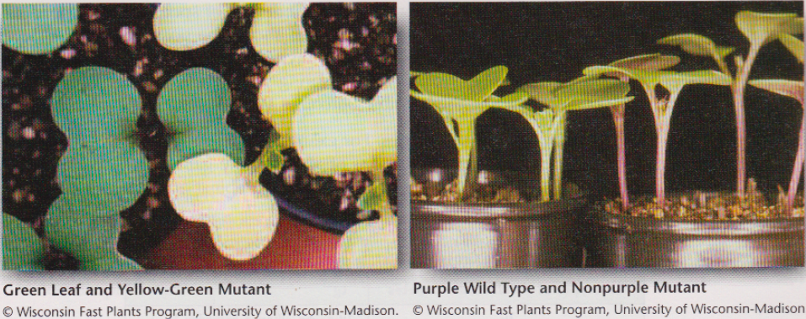

**Part I: Planting WFP Seeds**

1. In your notebook, show the entire problem, including the Punnett Square for the proposed cross. Calculate the expected percent of F2 offspring from each phenotype resulting from crossing F1 parent plants, which are heterozygous for green leaf color, and for purple color, anthocyanin, in the stems.
2. Plant and grow the F1 (GgAa) seeds. See the planting instructions below. Start on a Monday or Tuesday to ensure daily watering until the seeds have germinated.
3. Prepare the water reservoir (see figure 10.7). Fill the reservoir 2/3 full with tap water. Add 3 mL of liquid detergent. Soak the mat in the soapy water for 1 minute. Squeeze the soapy water out of the mat. Repeat this process for a total of three times. After the last soaking, do not squeeze out the mat. Lay the soapy mat on the cover of the water reservoir so that the long mat tip will hang into the water reservoir. Make sure that the mat makes good contact with the cover and that no air bubbles are under the mat. If you are reusing a reservoir and mat, dunk it in 10% bleach for 15 minutes, and rinse well with water before use.
4. Fill the water reservoir with tap water.
5. Place one copper sulfate anti-algae square in the reservoir water.
6. Place the reservoir cover, with the mat, on the reservoir, so that the mat is in the water.
7. 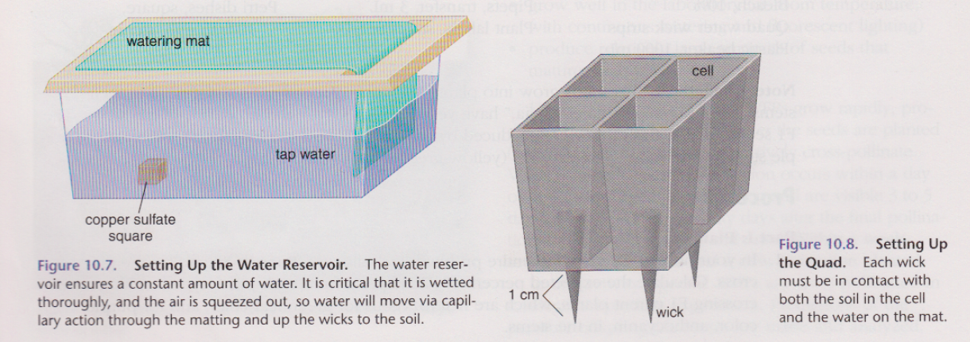Prepare the potting soil mixture by moistening it in a plastic beaker until it is slightly damp.
8. Locate a Styrofoam quad and label it with labeling tape (do not write directly on the Styrofoam quad). Use permanent marker. If you are reusing a quad, scrub it with soapy water, dunk it in 10% bleach for 15 minutes, and rinse well with water before using.
9. Obtain 4 wicks, and push one wick into each cell until the wick tip extends 1 cm through the hole in the bottom of the quad. When a wet wick touches a wet mat, capillary action will draw the water into the quad.
10. Fill each cell of the quad or pot ½ full with moistened potting-soil.
11. Obtain 12 fertilizer pellets and add three to each cell in the quad.
12. Fill each cell to the top with more potting mix. The soil should be loose, not packed down. Use a pencil to make a 4-mm depression in the soil surface of each cell.
13. Place three seeds into each depression, close but not touching.
14. Add just enough of the moistened potting soil to each cell to barely cover the seeds.
15. Using a pipet, water each quad thoroughly, but gently, until water drips out of the bottom of each cell. The soil and wick must be thoroughly wetted.

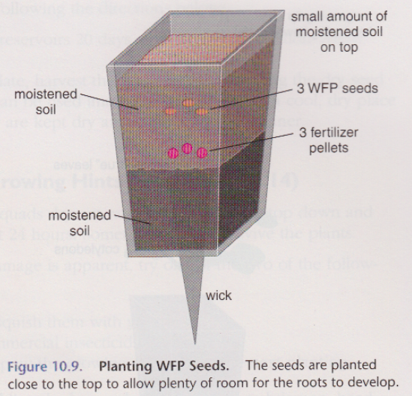

**Part II: Growing Wisconsin Fast Plant Seeds and Plants**

1. Place the quad on the water mat. Make sure that the wetted wick is in contact with the wetted mat. As other quads are added to the mat, make sure that all wicks are still in contact with the mat. Water each cell from the top before leaving the lab.
2. Place the water reservoir under the light bank. The top of the quad should aways be 5 to 8 cm from the bulbs of the light bank. WFPs are very sensitive to insufficient light. As the plants grow, try to keep an average distance of about 6 cm between the plants and the light bank.
3. Once the WFP seedlings are showing the first set of true leaves, thin them out to maintain one planet per cell by pinching the unwanted plants off with your fingernails. Create a data table to monitor stem growth over two weeks, measuring from the attachment of the first set of true leaves to the tip.
4. If necessary, use small wooden stakes to support plants as they grow. When flower buds appear, make bee sticks as directed.

**Part III: Pollination of Plants and Harvesting F2 seeds:**

1. Cross-pollinate F1 plants using premade bee sticks:
2. Make the bee-sticks at least 24 hours in advance to allow the glue fumes to evaporate. Using white glue, glue the honeybee thorax (excised from a bee’s body) onto a toothpick.
3. Holding the toothpick end of the bee stick, rotate the bee-thorax end over the stamen of the flowers to pick up pollen.
4. Cross-pollinate other flowers by rotating the bee stick on other flower pistils. Continue to pollinate in this way for 2 to 3 days.
5. After 3 days of cross-pollination, remove all unopened flower buds. Record the date of the last cross-pollination in your notebook. Continue to remove all new flower buds, being careful not to disturb the developing seed pods.

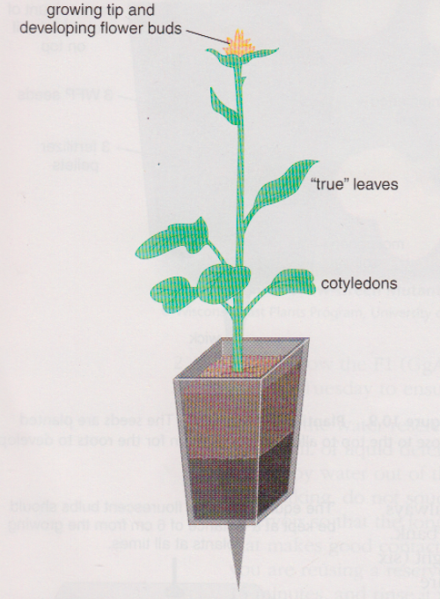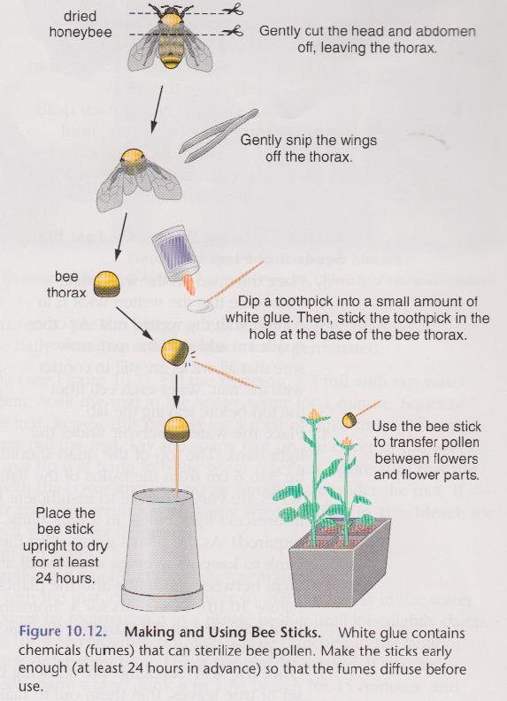

1. Harvest the F2 seeds from their pods following the directions below:
2. Remove the quads from the water reservoirs 20 days after the last pollination. Allow them to dry for at least 5 days.
3. Using a petri dish as a collection plate, harvest the seeds by gently rolling the dry seed pods between your hands. Seeds can be used immediately or stored in a cool, dry place for several months or more, if they are kept dry and in an airtight container.
4. Observe the results of the dihybrid, heterozygous cross by planting the F2 seeds (offspring of the F1 starting seeds). Grow them until the pigments in the stem and cotyledons are visible and obvious (within the first 3 days of germination). Follow the same planting instructions used for the F1 generation, except that before the next planting, soak the water reservoirs, platform, water mat, quads, and wicks in a 10% bleach solution for at least 15 minutes. Then scrub the quads with a brush and rinse all materials thoroughly with water. Let all the materials dry completely before reusing. Also, if there is a shortage of quads, plant five seeds per cell. The more seeds available to count give a larger sample size, which increases the validity of the results and multiple plantings are suggested.
5. Once the F2 plants have sprouted enough for you to recognize their phenotypes (at least third day), count the number of plants in each of the four expected phenotypes: 1) green with anthocyanin, 2) green with no anthocyanin, 3) yellow-green with anthocyanin, and 4) yellow-green with no anthocyanin. Record these data (for the plants in your quad) in a data table. If you are not sure of the phenotype of a certain plant, ask a colleague or two for their opinions.
6. Determine the expected number of offspring in each phenotype group and compare that number to the observed number of offspring in each phenotypic group. Remember that the percentage of each expected phenotypic group was calculated in the dihbrid punnet square. Record this information in the data table. Determine whether the observed data are within 10% of the expected values. Add this information to the data table.
7. Create a data table to show all the phenotypic data for the class. Record each group’s observed and expected values, and the observed and expected totals for the class. Make a bar graph of the observed and expected values (totals) for the class.

**HOW CAN YOU DETERMINE IF THE WFP DATA ARE GOOD ENOUGH?**

**Background**

In the WFP experiment, a known F1 generation of WFP was grown. These F1 plants were dihybrid, heterozygous for green leaves, and anthocyanin in the stems. Do you remember the genotypes of these plants.

When these F1 plants flowered, they were cross-pollinated with other F1 plants of the same genotype. Based on a large sample size and random breeding, the Punnet Square of this cross-predicted a 9:3:3:1 ratio of offspring in each phenotypic group. Thus, in any population of F2 offspring:

9/16 are expected to show the dominant/dominant traits of green with anthocyanin

3/16 are expected to show the dominant/recessive traits of green, no anthocyanin

3/16 are expected to show the recessive/dominant traits of yellow, with anthocyanin

1/16 are expected to show the recessive/recessive traits of yellow, no anthocyanin

We rarely get only 16 offspring, so it is more useful to consider the percentage of the offspring in each phenotypic group. Therefore, in any given population of offspring we expect the following:

56%(9/16) to show the dominant/dominant traits = green, with anthocyanin

19%(3/16) to show the dominant/recessive traits = green, with no anthocyanin

19%(3/16) to show the recessive/dominant traits = yellow, with anthocyanin

6%(1/16) to show the recessive/recessive traits = yellow, with no anthocyanin

Thus, in a population of 200 offspring, the following are expected:

112 are expected to be green, with anthocyanin (200 x .56)

38 are expected to be green, with no anthocyanin (200 x .19)

38 are expected to be yellow, with anthocyanin (200 x .19)

12 are expected to be yellow, with no anthocyanin (200 x .06)

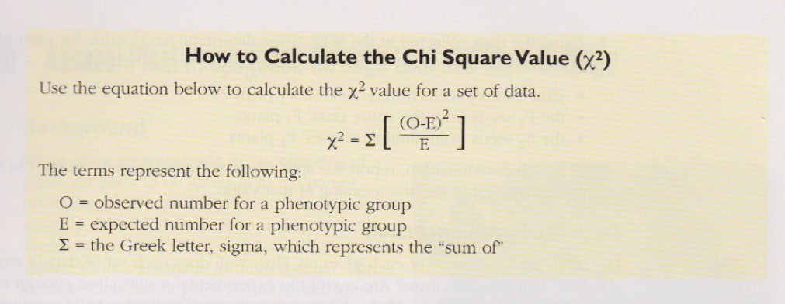

You may have more or fewer seeds than you expect as F2 offspring in each phenotypic group from your F1 plants. Though a Chi Square (χ2) analysis of the phenotypic results of the F2 offspring, the validity of the data collected from the dihybrid, heterozygous cross can be evaluated.

The χ 2 equation examines and compares each phenotypic group’s observed data to the expected results. The difference is the deviation between the actual and the expected results. Then, Σ sums up all of the phenotypic group’s deviations.

The final x2 value represents the sumof all of the deviations in the experiment, By looking on the Chi Square probability table (Table 10.4), one can see if the observed deviation from the expected results is small enough that it supports the experimental hypothesis and that there is no significant difference between observed and expected data. In this case, the hypothesis is that the data are similar enough to be considered a valid dihybrid, heterozygous cross (see table 10.4). If the χ 2 value is too large (greater than the P = 0.05 value), the deviation from what is expected odd p large that the data do not support a valid dihybrid, heterozygous cross.

**PURPOSE**

Does the χ 2value for the WFP cross support the hypothesis that a dihybrid, heterozygous cross was conducted in the WFP breeding experiment by showing that there is no significant difference between observed and expected results.

**PROCEDURE**

1. Determine the degrees of freedom (df) for the WFP dihybrid, heterozygous cross. The df is one less than the number of phenotypic groups.

2. Using all data collected in the WFP cross, determine an χ 2 value for each of the following. Show all calculations for each χ 2 determination in your notebook.

* Your own F2 seeds from your own F1 plants
* The F2 seeds from the entire class’ F1 plants
* The F2 seeds from multiple classes’ F1 plants

3. For each determination, report the spot where the χ 2 value falls on the Chi Square Probability Table and the meaning of that value.

