Name:
Date:
Period:

A Simulation Game for the Study of Enzymes Kinetics and Inhibition

This simulation game facilitates understanding of aspects concerning enzyme kinetics and inhibition.

The first part of the game deals with the relationship between enzyme activity and substrate concentration.

The second part of the game concerns characterization of competitive and noncompetitive inhibition of enzyme activity.

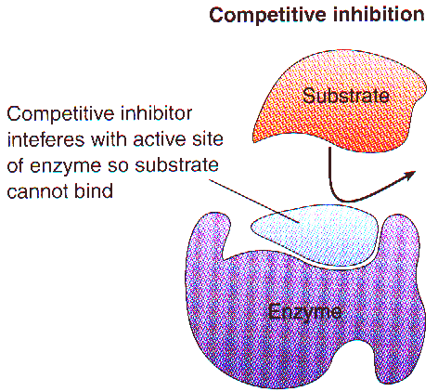

In competitive inhibition, the inhibitor resembles the substrate and carries out reversible binding, but the reaction actually does not occur once the inhibitor is bound. While the inhibitor occupies the active site, it prevents binding by the substrate until the release of the inhibitor from the enzyme takes place.

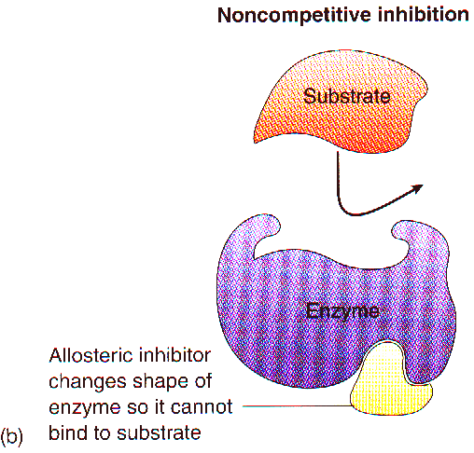

In noncompetitive inhibition, the inhibitor binds to the enzyme in a form that causes changes in the enzyme configuration and results in a partial inactivation of the enzyme.
Materials:
- 100 colored coins (i.e. pennies)
- 10 uncolored coins (i.e. nickels)
- Stopwatch
- Adhesive tape
- A cloth for blindfolding

Part 1: Simulation of the relationship between enzyme activity and substrate.

- Divide into groups of 4 students, each group sitting around a table.
- Blindfold one of the four students at the table.
- Scatter 10 colored coins more or less evenly on the table, representing the substrate concentration.
- A second student operates a stopwatch and measures exactly 30 seconds during which the blindfolded student collects coins with one hand and places them in a box held with his/her second hand. Count the number of colored coins the student collects in the box.
- The same procedure is repeated by the same student, spreading out 20, 30, 40, 50, 60, 70, 80, and 90 colored coins on the table. The colored coins are counted after each repetition of the game. Multiply the count by 2 in order to get the number of colored coins collected during one minute, a value representing the enzyme activity.

Number of Colored Coins Spread on Table  (Substrate Concentration) | Number of Colored Coins Collected During Simulation | Rate of Colored Coins Collected (Colored Coins per Minute = Enzyme Activity)
10
20
30
40
50
60
70
80
90

- Graph your results

Part 2: Simulation of competitive inhibition of enzyme activity.

- Repeat the simulation of the relationship between enzyme activity and substrate concentration (part 1). This time, spread out an additional 10 uncolored coins among the different numbers of colored coins.

Number of Colored Coins Spread on Table  (Substrate Concentration) | Number of Colored Coins Collected During Simulation | Rate of Colored Coins Collected (Colored Coins per Minute = Enzyme Activity)
10
20
30
40
50
60
70
80
90

- Graph your results.

Part 3: Simulation of noncompetitive inhibition of enzyme activity.

- Repeat the simulation of the relationship between enzyme activity and substrate concentration (part 1). For this part, bind together three of the middle fingers of the hand of the blindfolded student (the hand that collects the coins).

Number of Colored Coins Spread on Table  (Substrate Concentration) | Number of Colored Coins Collected During Simulation | Rate of Colored Coins Collected (Colored Coins per Minute = Enzyme Activity)
10
20
30
40
50
60
70
80
90

- Graph your results.

Discussion Questions:

- What is the relationship between enzyme activity and substrate?

- What is competitive inhibition? What is noncompetitive inhibition?

- What part of the lab represented each?

- What factors could slow down the rate of a reaction?

This activity is taken from Reuben Chayoth, Ph.D., and Annette Cohen, Ph.D., teachers in the Department of Life Sciences, Ben Gurlon University of Negev, Beer-Sheva, Israel 84105.

