**Wisconsin Fast Plants – How Fast is Fast?**

Purpose: Discover/learn the life cycle of *Brassica rappa*, or Wisconsin Fast Plants prior to growing them in lab.

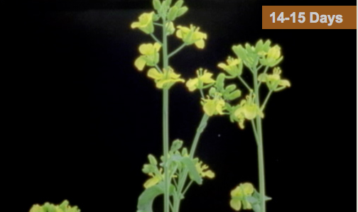

TO DO: Use the internet to gather background information about the life cycle of a “model organism” commonly used in lab, *Brassica rappa*.

1. Find a picture representation of the complete life cycle of one generation of *Brassica rappa*. A circular, life-cycle diagram is preferred. Print the diagram and glue in your notebook.

2. Find an article on the Internet that describes the major events in the life-cycle of *Brassica rappa*. Print the article and glue in your notebook.

3. Use the diagram and article to fill out a timeline chart you create in Google or Excel like the one below (NOTE: this timeline is more than one generation of *Brassica rappa*):

|  |  |
| --- | --- |
| Time (days) | Description of *Brassica rappa’s* Life Cycle Events |
| 0 |  |
| 2 |  |
| 5 |  |
| 7 |  |
| 10 |  |
| 13 |  |
| 15 |  |
| 20 |  |
| 23 |  |
| 36 |  |
| 56 |  |